Module: 5 - Spring Core and Maven

Exercise 1: Configuring a Basic Spring Application

pom.xml
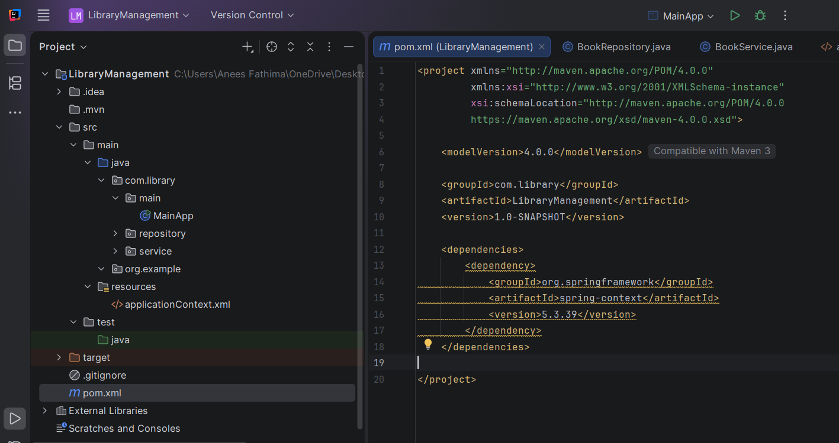

BookRepository.java
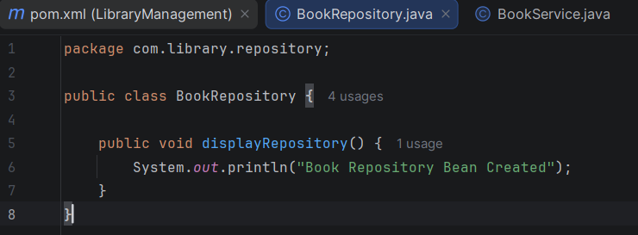

BookService.java
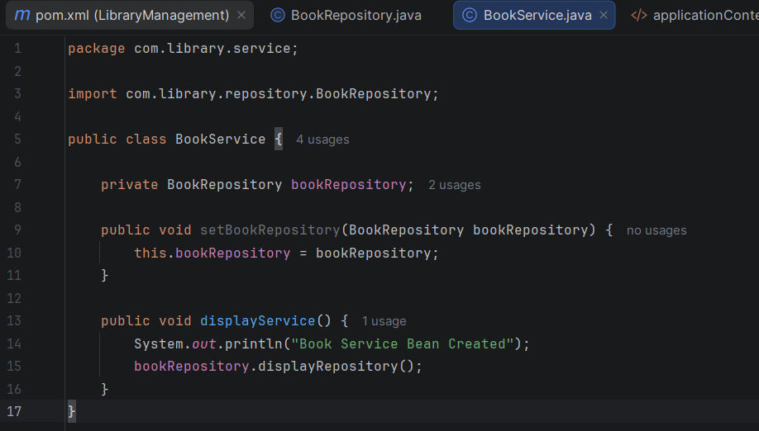

MainApp.java
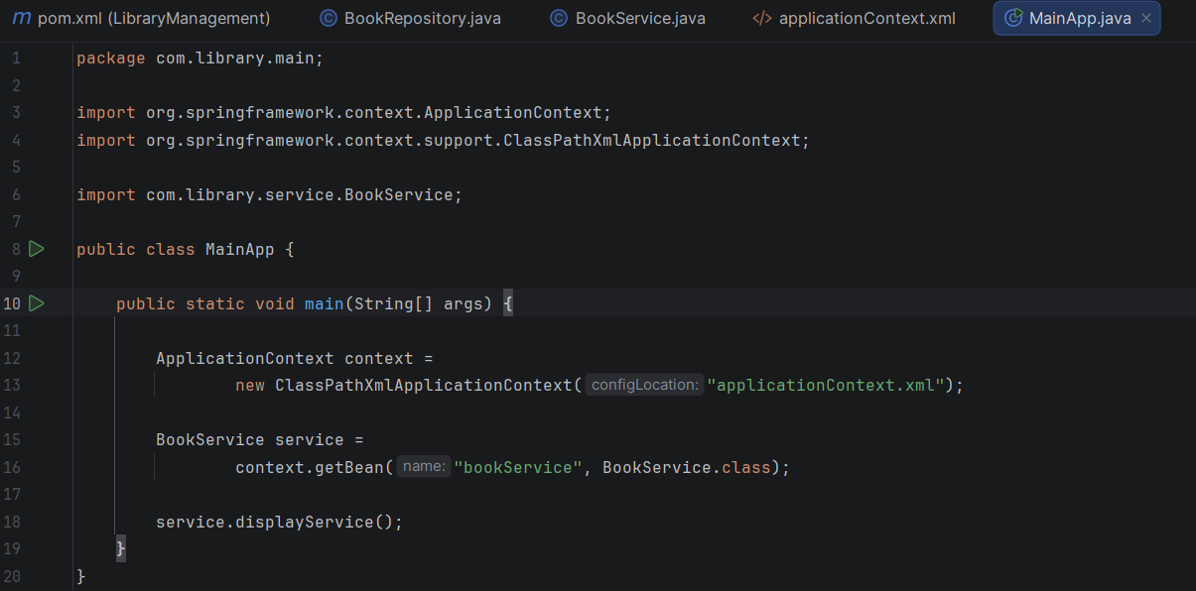

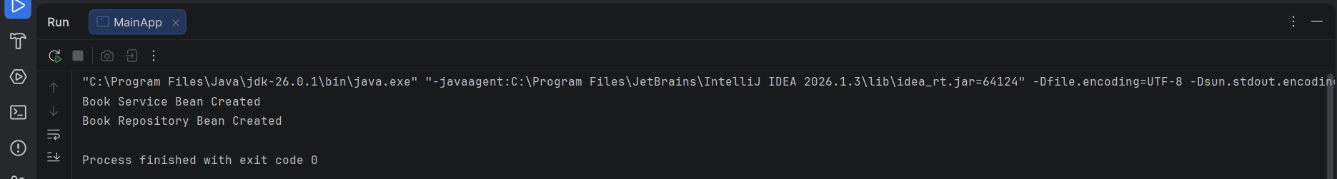
Output

Exercise 2: Implementing Dependency Injection

BookRepository.java
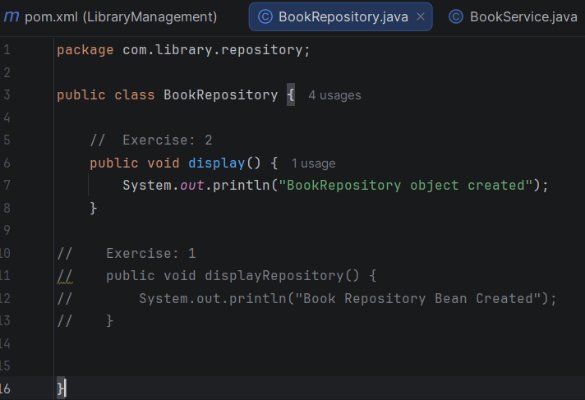

BookService.java
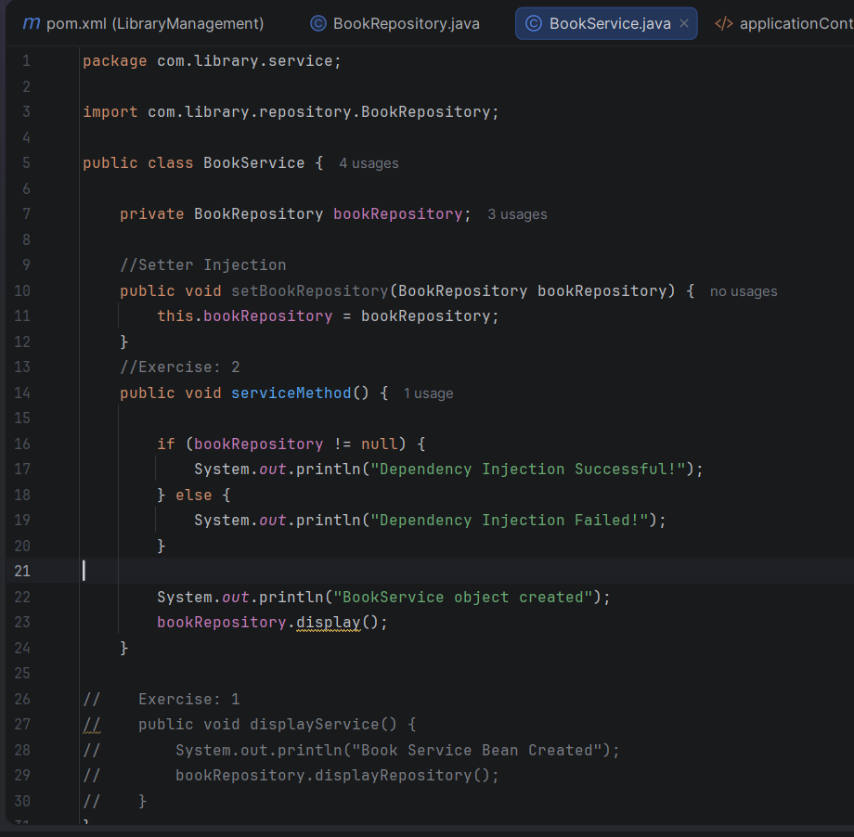
MainApp.java
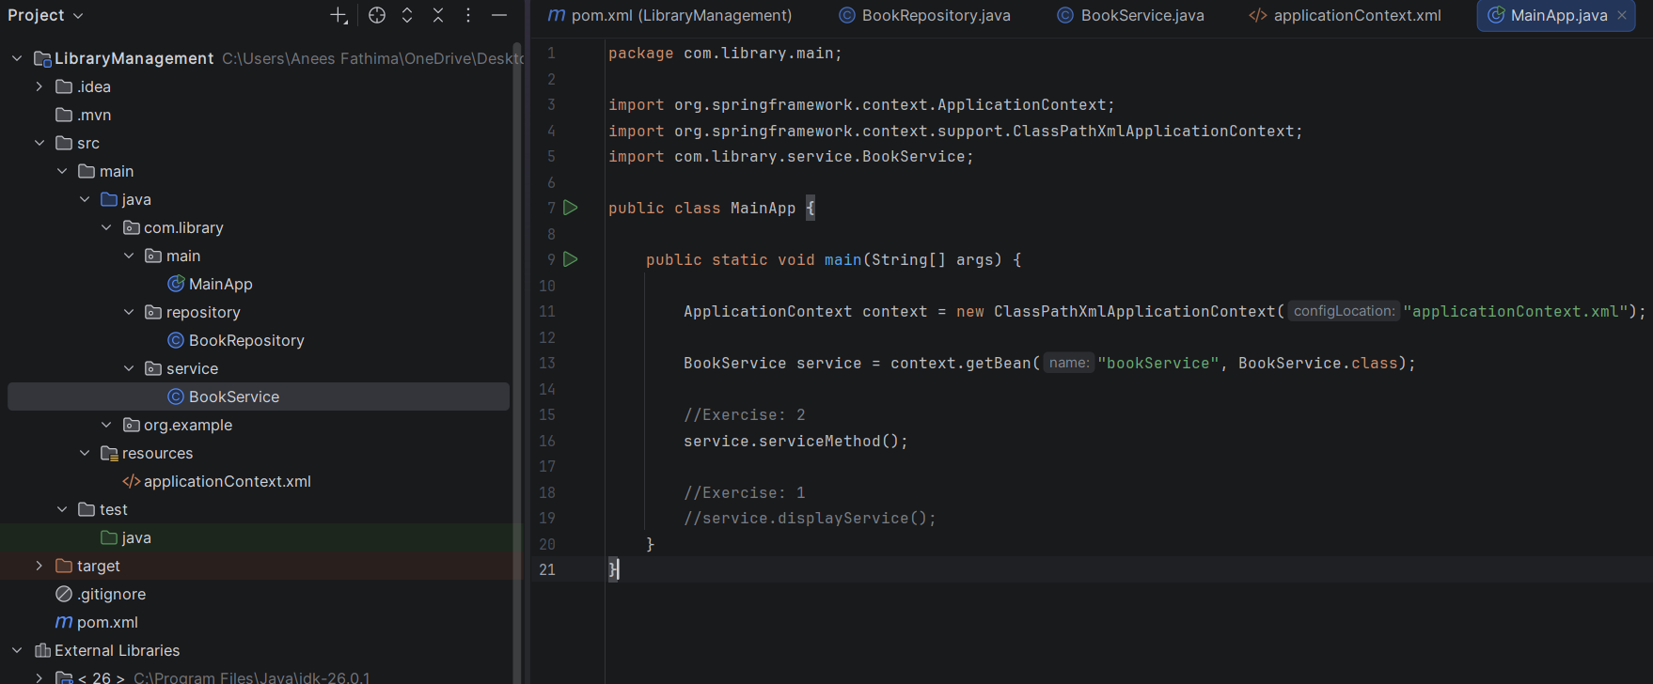

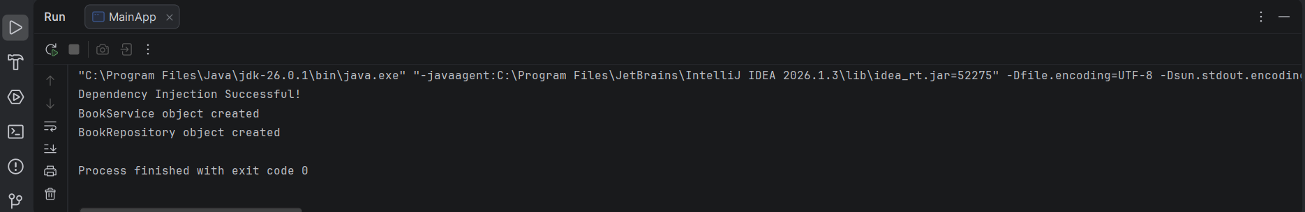
Output

Exercise 4: Creating and Configuring a Maven Project

pom.xml
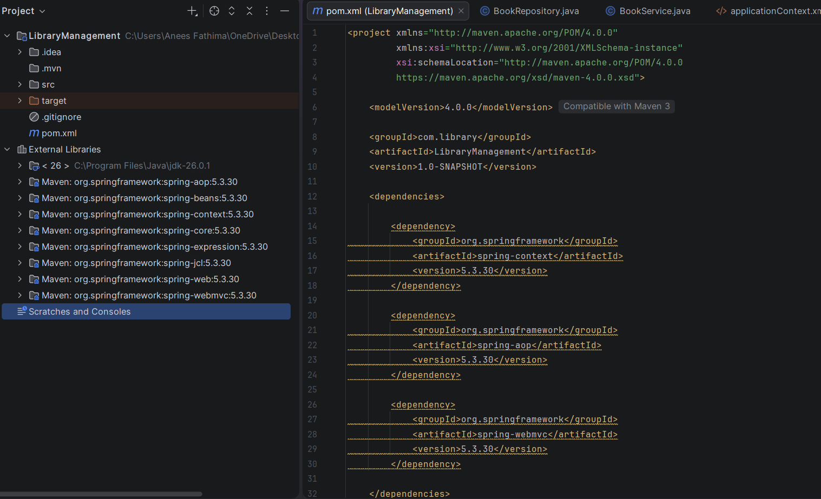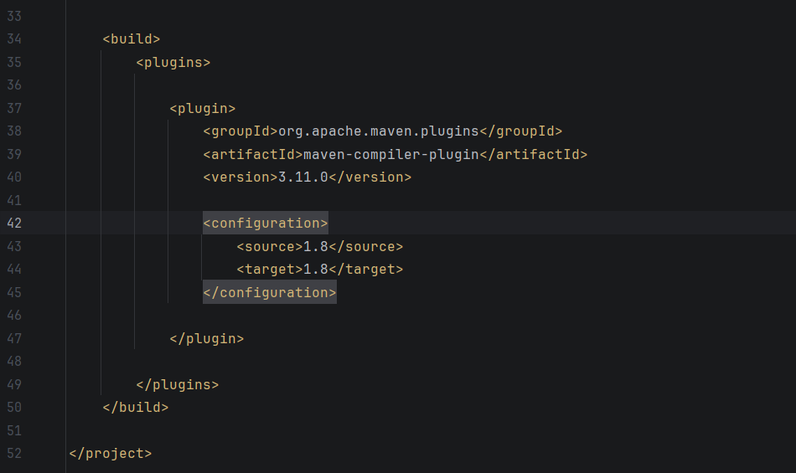

Output
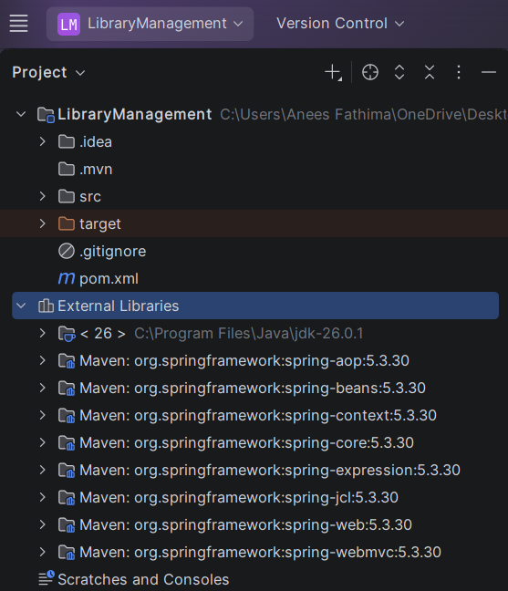

Module: 6 - Spring Data JPA with Spring Boot, Hibernate

Hands-on 1: Spring Data JPA - Quick Example

Country.java
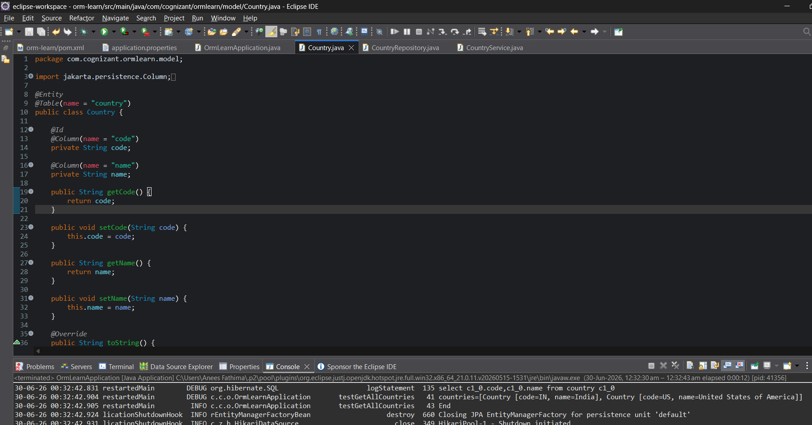

CountryService.java
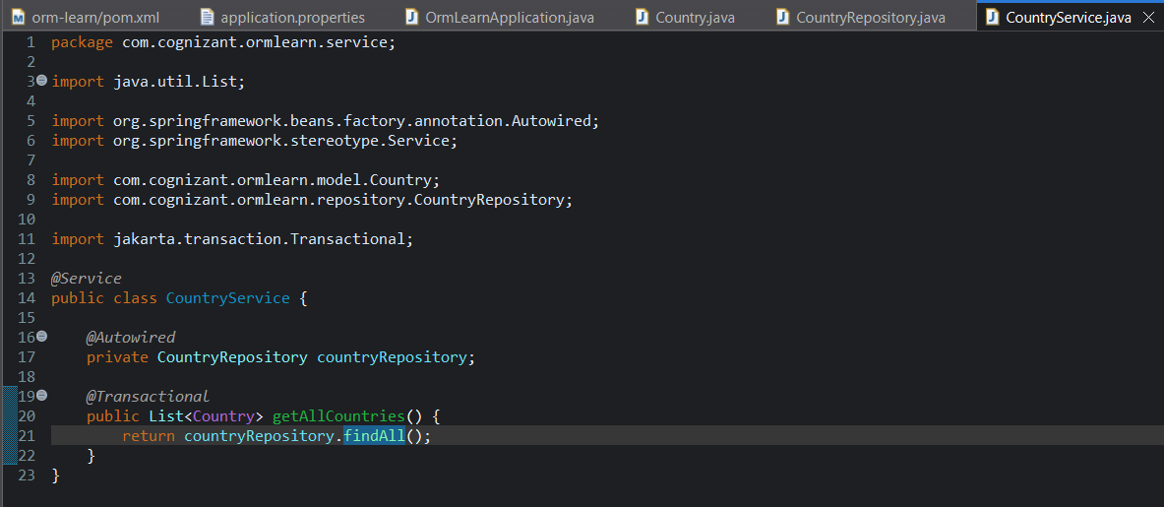

CountryRepository.java
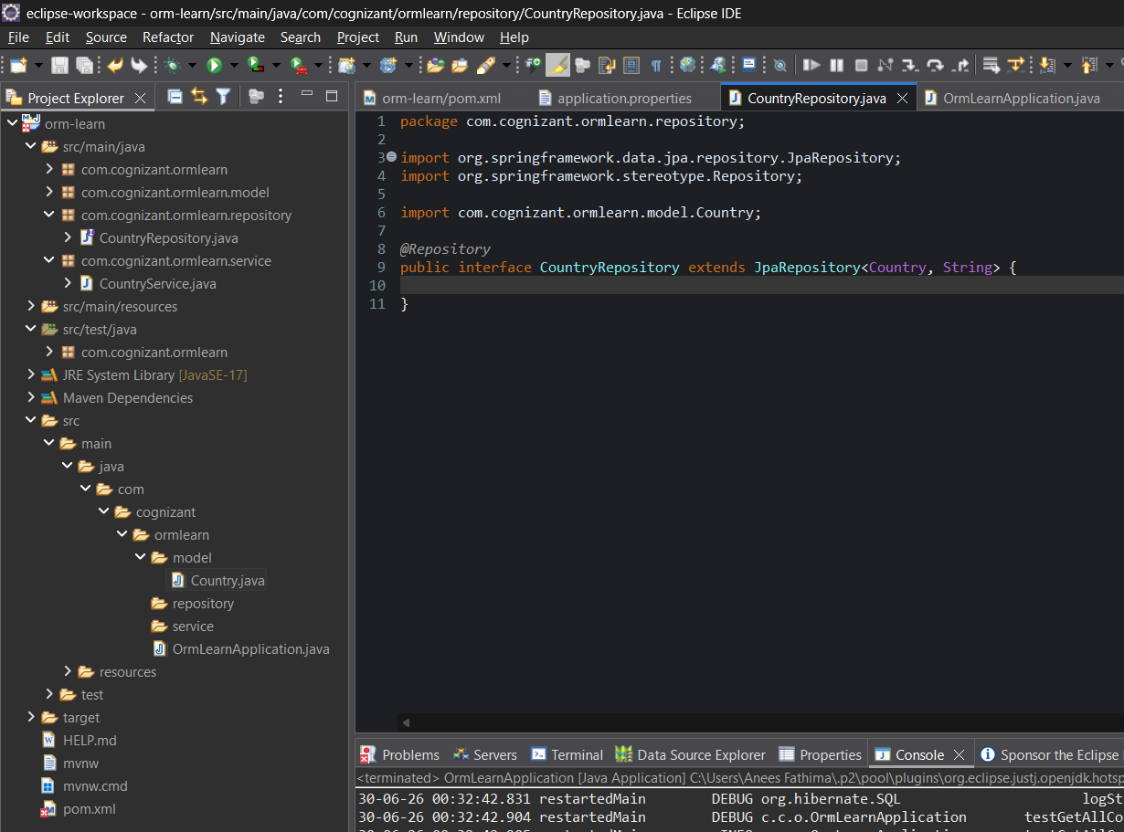

application.properties
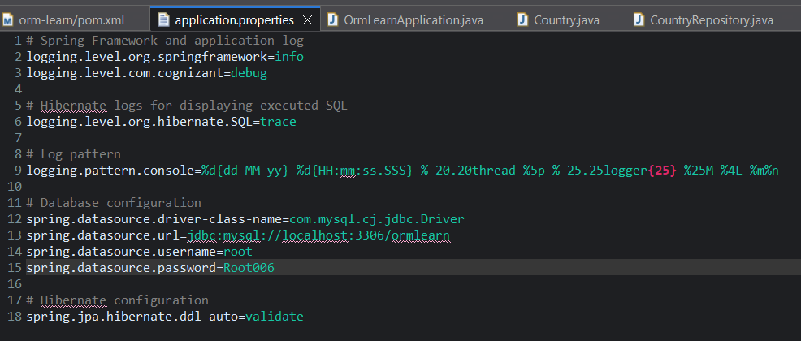

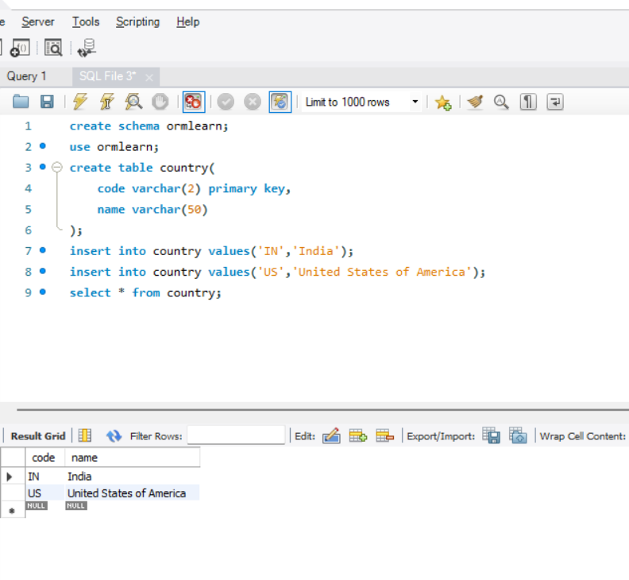
Script file
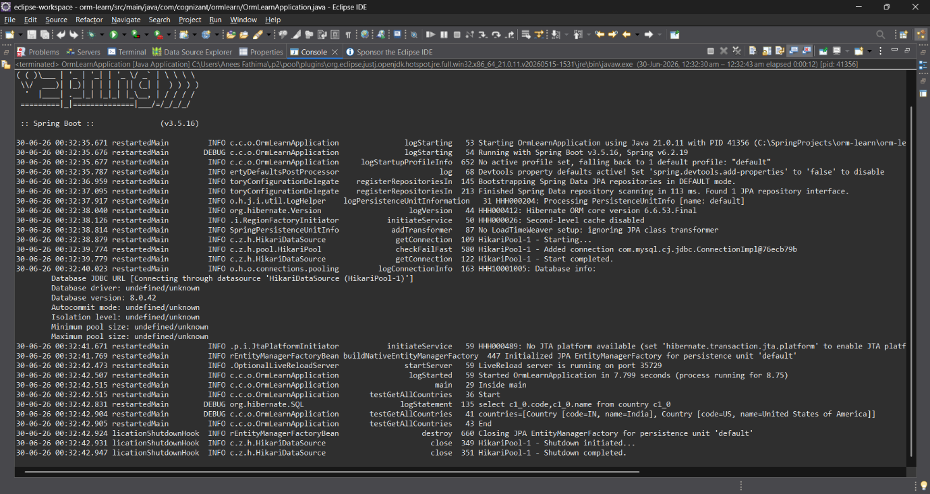
Output

Hands-on 4: Difference between JPA, Hibernate and Spring Data JPA

JPA
- Java Persistence API (JPA) is a specification for object-relational mapping.
- It defines standards for persisting Java objects.
- It does not provide an implementation.

Hibernate
- Hibernate is an ORM framework.
- It implements the JPA specification.
- It maps Java objects to database tables.

Spring Data JPA
- Spring Data JPA is an abstraction layer over JPA.
- It reduces boilerplate code.
- It provides interfaces such as JpaRepository.
- It automatically manages transactions and common CRUD operations.

Feature | JPA | Hibernate | Spring Data JPA
What is it? | Specification (API standard) | ORM Framework | Abstraction over JPA
Implementation | No | Yes | No
Boilerplate Code | More | More | Less
Transaction Management | Not directly | Manual | Automatic with @Transactional
Query Methods | Manual | Manual | Auto-generated
Example | EntityManager | Session | JpaRepository

Relationship
Java Application
↓
Spring Data JPA
↓
Hibernate (JPA Implementation)
↓
MySQL Database

Hibernate Example:
Session session = factory.openSession();
Transaction tx = session.beginTransaction();
session.save(employee);
tx.commit();
session.close();

Spring Data JPA Example:
public interface EmployeeRepository extends JpaRepository<Employee, Integer> {
}
@Transactional
public void addEmployee(Employee employee) {
employeeRepository.save(employee);
}
JPA Example:
EntityManager em = entityManagerFactory.createEntityManager();

